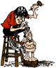
OCWC News
2019 Officers
Pres Ron Nicholson
V. Pres Fred Self
Sec Dan Nealey
Treas John Amicon
Oklahoma City Woodcarvers Club

Vol. LIV No. 6

>REMINDERS
Next Meeting – 7:00 Monday, June 10th at the usual location on the Fairgrounds.
All subsequent meetings will be held at Will Rogers Garden Exhibition Center on the fourth Tuesday of each month, beginning June 25. Please see the last page of this newsletter for a map and directions.

Monday, June 10th:
Topic of meeting: Evan Vincent, our new knife maker, will demonstrate knife sharpening.

Refreshments: Coffee
Door Prizes: Ralph Green
Hospitality: first volunteer

Gerald Hudson gave an interesting and informative talk on chip carving at our May meeting. Here are a few examples of his work:
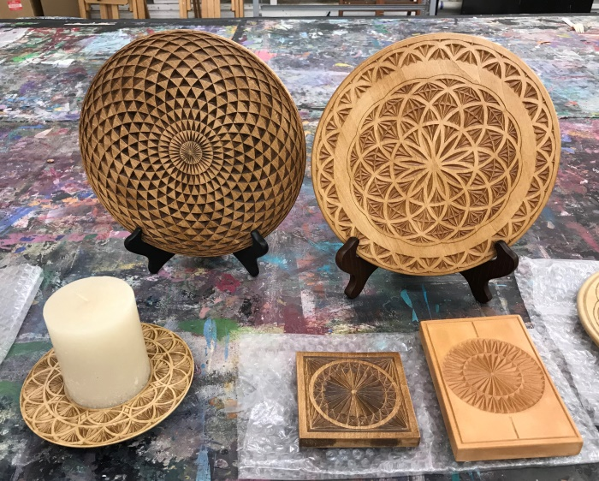
The plate in the upper left was on the cover of Chip Chats.

Preferring to create his own designs, he doesn’t use patterns. Instead, he plans his motifs using quadrille paper and then sketches directly onto the wood.
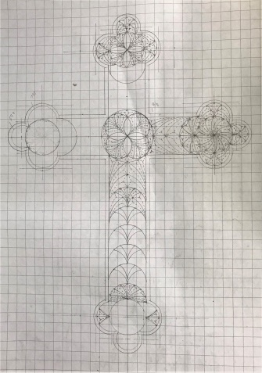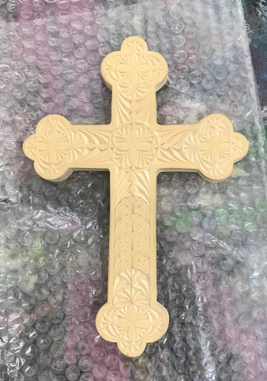

All of his carvings are done in bass wood, so he generally uses H or HB pencil lead. He explained that a harder lead would mar the surface, and a softer lead would smudge more easily and create a line that was less precise.

A few of the other tools that he uses for drawing include a compass, a triangle, and a ruler. After he’s done carving, he finishes his work with Classic Wax, which creates a protective coating and adds color to the recessed areas.

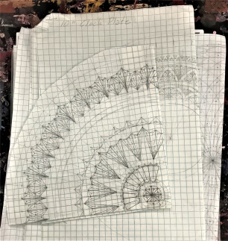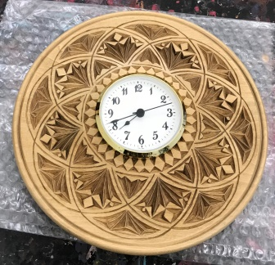

From start to finish, Gerald combines technical precision with artistic inspiration to create beautiful, detailed carvings.
For show and tell, four of our members brought items to share with us:

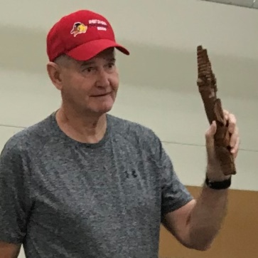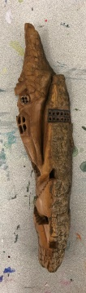
Ron Nicholson brought in a bark carving of a house that he carved from red cedar.

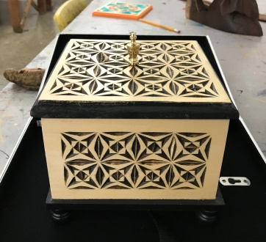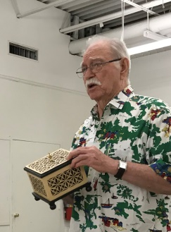
DJ Boyce shared another of his chip carved boxes. Always good for a laugh, he also shared an attempt he made at adding a little color to one of his pieces that didn’t go over very well with his family. He also brought a carved wooden bear puppet that one of his daughters found at a thrift store.
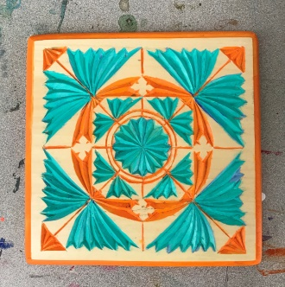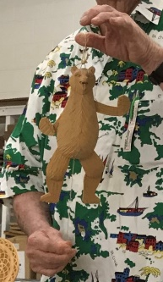

Bill Dalke shared three of his carvings:
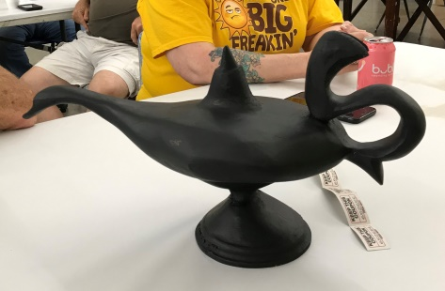
Here is a genie’s lamp that he carved as a stage prop for his daughter’s play.
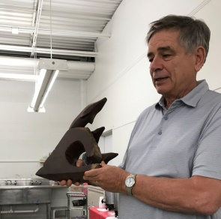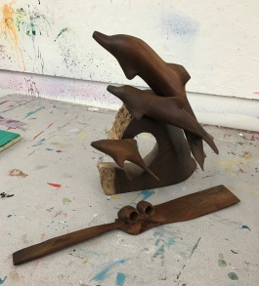
He also shared a carving of three dolphins jumping with a breaking wave. Finally, he shared a wooden cake knife that he carved.

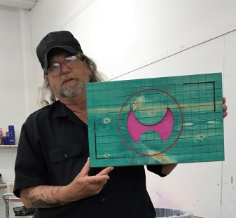
Keith Newark brought a brightly colored abstract carving with circles and squares.

In remembrance…
Lifetime OCWC member and master bird carver Ron Schessl passed away on April 22.
His obituary is available online at:
https://www.legacy.com/obituaries/oklahoman/obituary.aspx?pid=192728322.

NOTES from President: With regret I must resign as club president for personal reasons. God bless, Ron Nicholson

COMING EVENTS
Broken Arrow, OK – The Woodcarving and Folk Art Festival will be held June 21 & 22.
Rogers, AR – The Woodcarvers of Northwest Arkansas show will take place Sept. 7 & 8.
Wichita, KS – Great Plains Woodcarvers Annual Woodcarving Show & Sale will be Oct. 5 & 6.

CONTINUING PROJECTS
COMFORT BIRDS: If you have any more finished birds, please give them to Clyde Fosdyke. If you give any birds directly to others rather than going through Clyde, please provide him with their names and pictures of the birds whenever possible.

Bill Dalke reminded us that even though we don’t get much feedback, the comfort birds that we donate are truly appreciated.

Hospitality
A special note of appreciation goes to the ladies who tend to the coffee service at our meetings and keep track of the members who attend. Thank you, Pat Priest, for always coming in early to brew coffee and for taking attendance at meetings and carve-ins. A special thank you goes to Jackie Hitchcock for helping Pat with the coffee.

See you all MONDAY, June 10, at 7 pm.

Subsequent meetings will be held at 7:00 pm the fourth Tuesday of each month at Will Rogers Garden Exhibition Center.
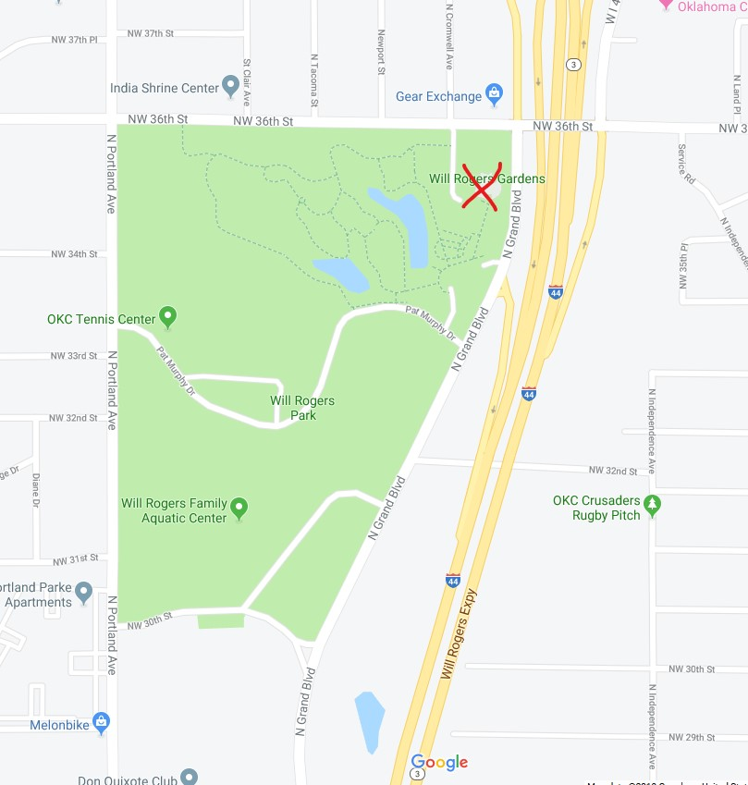
The red “X” marks the spot.
From the south, take I-44 north past the fairgrounds. Take the NW 36th Street exit and turn left (west) at the light and cross over the freeway. To access the north parking lot, turn left in to the driveway a short distance past the freeway. To access the south parking lot, turn left (south) on Grand Blvd after crossing the bridge. The south parking lot will be on the right just before the I-44 onramp.

From the north, take the westbound 39th Street Expressway exit. Turn left (south) at Portland. Turn left (east) on 36th Street. The north parking lot will be on the right just before Grand Blvd. The north parking lot can be accessed directly from 36th Street. To access the south parking lot, turn right on Grand. The parking lot will be on the right just before the I-44 onramp.

Website: www.okcarver.org

