**Presidential Papers**

***September Board of Directors meeting*** –   
  
Tuesday, September 14, 2010, 7:00 PM at the Panara Bread at North Western and 67th Street.

***Board of Directors***   
  
We voted in August to propose an increase in the Club’s dues from $15 to $24. The membership will be asked to vote on the proposal at the October regular meeting.

***BIG THINGS FOR SEPTEMBER 11TH***

***Annual Club Picnic***   
  
will be held again at the Stephens Park in Edmond again this year on Saturday, September 11.

***Oklahoma History Center Demonstration***   
  
comes on the same day as our picnic again this year. This is the second annual participation in this event at the State History Center just northeast of the State Capitol Building. Those wanting to participate contact Pete Zachry at 732-2888 or 501-5390. Those at the picnic are welcome following that event.

***Midwest City Library Demonstration***   
  
is the third event of Saturday, September 11th. The month long exhibit began September 1st but the actual demonstration was delayed because of Labor Day. Those wanting to take part should contact Earl Cox.

***Special Thanks to Shearlene Tibbets*** for her service as Club Librarian. Her situation has precluded her attending meetings as regularly as she would like and has ask that she be replaced. During her term, the library has continued to be a highly valuable asset of the Club.

***Gary James and Sam Escobedo***   
  
have agreed to take up the reigns as librarians so we will continue to have one of the best collections of woodcarving references around. If you are not familiar with our Library, you should take a little time to look it over at the next club meeting.

***Nomination Committee***   
  
is busy getting volunteers to fill the positions that ensure the continuation of the Club’s activities in the coming year. If you are willing to serve as an officer please call Earl Cox, John Amicon, or Gary James. If asked, please accept the challenge of serving for a year or two. Serving as an officer is not really a burden, but is actually a lot of fun and you can gain a feeling of accomplishment while helping your friends.

C:\Users\OKCarver\AppData\Local\Microsoft\Windows\Temporary Internet Files\Content.IE5\3NBE93TP\MC900301330[1].wmf

 Show and Tell  
Walt Lagrone displayed his cane carved with Yaupon Holly.   
David Rogers presented his carving of Willie and Joe done in the Futterer class in August.  
Ken Ferrell showed his Walnut cane with a Gargoyle handle.  
Wayne Davis showed three crosses.  
Sam Escobedo brought his small carvings of a Shark and a Stingray  
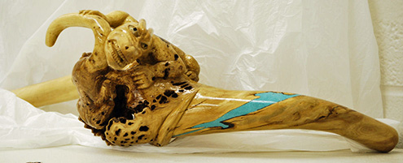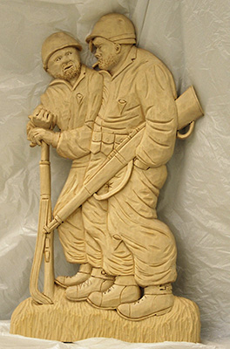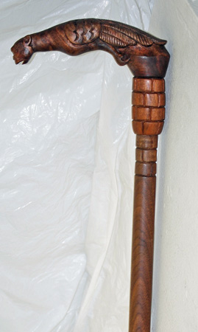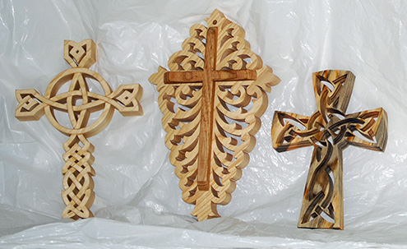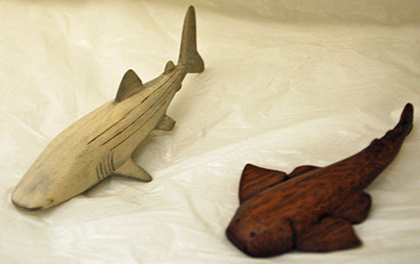

**Bob and Lillie Neal Honored**

Bob and Lillie Neal were honored for their long time participation in OCWC activities.  Bob has been a member for longer than any other carver and has participated in more OCWC Woodcarving Shows than anyone else. Several carvers took part in the making of the Friendship Cane.  The cane has eleven sections, hand carved, and a bottom section of turned maple. The fun part was the chance for each member to tell their own story about Bob.  Quite a few of the members joined in and we all know him a bit better now.

Bob has more records to his name than those noted above.  He has the biggest (and best) collection of pocket knives of anyone in Oklahoma.  If you want to know something about your pocket knife, Bob is the man.  Even if it’s your Great Grand Daddy’s knife, Bob can tell you about that as well.  He carves with pocket knives. One carving that is always admired is a peach seed carved into the “End of the Trails” Indian.  You won’t catch him with basswood very often. He loves hard and dense woods, the harder the better.  He also has played more baseball and softball games than the rest of us put together.

If you have joined in the many carve-ins around Oklahoma City you may have seen him in action.  At the Wednesday carve-in many were carving a “ball in a cage” in old sewing thread spools so Bob went them one up by carving a “Gorilla in a cage” and he did it in less time.  Everyone was properly impressed.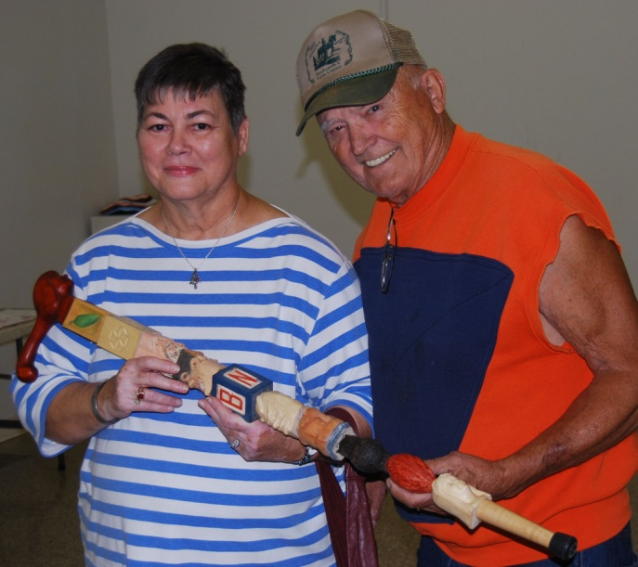

**Oklahoma City’s Woodcarving Show**

**“Artistry in Wood”**

***Oct. 30 & Oct. 31, 2010***

**Centennial Building, OKC Fair Grounds**

Oklahoma City, Oklahoma

**Judge – Dave Stetson**

***Featuring***

Whittling Contest -- Cash Awards -- Demonstrations

Door Prizes – Vendors – Purchase Awards

Contact

Richard Dalke, 4109 NW 146 st, Oklahoma City, OK 73134

Phone (405) 302-5102 E-mail redalke@gmail.com

www.okcarver.org

**OKCarver.org**

Check the web page for updated show INFO! In your browser URL enter this address: <http://OKCarver.org>

You can now get OCWC information with exciting full color images. Check it out!

Administrator email at: [administrator@okcarver.org](mailto:administrator@okcarver.org)

Contacts 2010

President: Zachry, 732.2888, cell 501.5390  
V. President: Dalke, 302.5102, cell 255.6168  
Secretary: Fosdyke, 751-0921  
Treasurer: Wallace, 722-6397  
NL Editor, Web page Admin: Tibbets, 834-8132  
Show Chair: Dalke, 255-6168

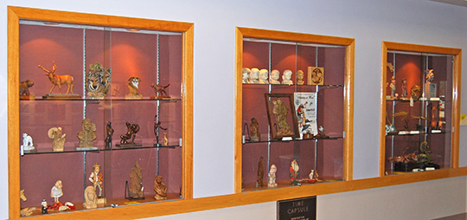

MidwestCity Library Display

